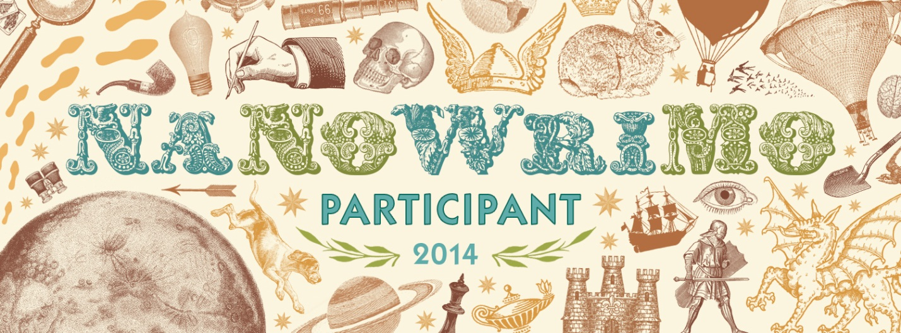

CHS Writing Group
The CHS Writing Group meets weekly on Tuesdays during lunch. This year we are participating in National Novel Writing Month in November. We work on exploring our creative writing avenues with peer critiques, brainstorming sessions, and a special library of writing materials. Writing isn’t just for November. We will be working on projects all year!

Join us!

